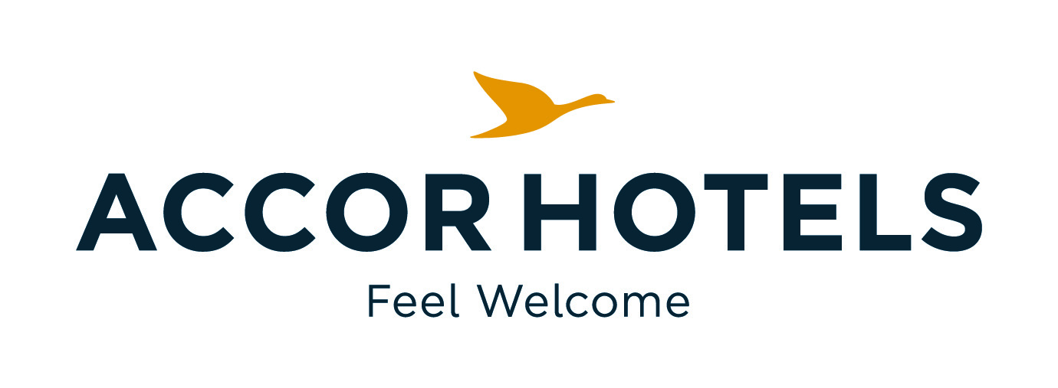
ibis budget Ambassador Busan Haeundae

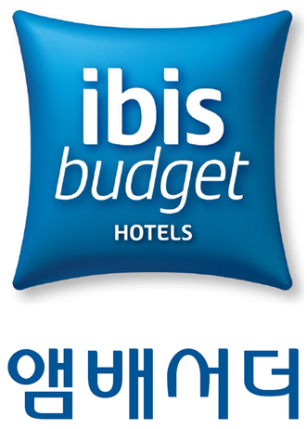
Korean Society of Nuclear Medicine
ibis budget Ambassador Busan Haeundae Reservation Form

- Room Type / Room Rate (Room only) / 11th of May 2018

Room Type | Bed Type | Room Rate | Acceptable pax | Remark | No. of Rooms
Standard Double(City) | 1 Double | 50,000 KRW | 2 | 10% TAX will be added
Standard Twin(City) | 2 Single | 55,000 KRW | 2 | 10% TAX will be added

- Room Type / Room Rate (Room only) / 12th of May 2018

Room Type | Bed Type | Room Rate | Acceptable pax | Remark | No. of Rooms
Standard Double(City) | 1 Double | 100,000 KRW | 2 | 10% TAX will be added
Standard Twin(City) | 2 Single | 105,000 KRW | 2 | 10% TAX will be added

- Breakfast

No. | Name of restaurant | Location | Menu | Price | Remark
1 | La Matinee | Lobby | Buffet | 11,000 KRW | 10% TAX will be added

Please fill out this registration form and send it back to h9106-re@accor.com
Name : | Country :
Phone Number : | E-mail :
Check In & Check Out date :
Breakfast(12,100KRW) : ( ) No of pax
Remark

- Payment Information

Credit Card Type & Number : | Expire date :

- Cancellation Policy
- If cancelled or modified up to 14-7 days before the date of arrival, 50 % of the 1 night will be charged.
If cancelled or modified up to 7-2 days before the date of arrival, 100 % of the 1 night will be charged.
If cancelled or modified up to 1 days–on check-in date or in case of no-show, all night room rate will be charged.
- If you cancel or no-show, cancellation fee will be charged automatically with the above credit card without notice.

